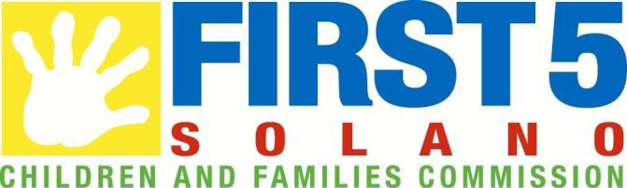

Annual Grants Program Request for Applications (RFA) #2024-01

RFA Issue Date: January 22, 2024

Written Questions Due: February 5, 2024 5PM PST

Mandatory Letter of Intent (LOI) Due:
February 12, 2024 5PM PST
Via Google Forms at:

https://forms.gle/h3z7jTbNQ5YYxEXF7

Mandatory Grant Development Sessions

February 12- March 1, 2024 by appointment via teleconferencing

(appointments will be scheduled following submittal of LOI)

Full Applications Due: March 11, 2024 5:00PM PST
Send by e-mail to
cfcsolano@solanocounty.com

RFA Coordinator:
Kwiana Algere kjalgere@solanocounty.com
www.first5solano.org

SECTION 1: SCOPE OF PROJECTS

Background/Overview
The First 5 Solano Children and Families Commission (First 5 Solano) is pleased to announce its Annual Grants Program. A total of $160,000 is available in the Annual Grants Fund for FY2024/25 through this Request for Applications (RFA #2024-01).
FIRST 5 SOLANO’S VISION
All children are healthy, eager to learn, and nurtured by strong families in safe and inclusive communities.

First 5 Solano’s 2023-2028 Program Investment Plan allocates $15.8 million in programmatic investment to support the Commission’s vision for Solano’s young children and generate tangible results for children and families. In this Program Investment Plan, the Commission allocated $120,000 for an Annual Grants Fund. The Annual Grants Fund is designed for one-time projects to address the needs of children ages 0-5, their parents/caregivers, and/or providers of services to children ages 0-5 in Solano County.

Available Funding
Grants of up to $20,000 per year are available through this RFA. The Commission has committed up to $120,000 in annual grants for FY2024/25. Multiple grants of up to $20,000 each will be awarded for up to a 1-year period from July 1, 2024 – June 30, 2025. Projects must be provided in Solano County and benefit children ages 0-5, their parents/caregivers, and/or providers of services to children ages 0-5. Funding may be requested for staff time (such as orientation, training, outreach, direct services, and evaluation activities), program supplies, administrative costs and other costs as agreed.

Connection to Commission’s Strategic Plan
All projects proposed for the Annual Grants Fund must connect to the Commission’s 2022 Strategic Plan Update.

Please refer to the First 5 Solano Commission strategic plan (https://www.solanocounty.com/civicax/filebank/blobdload.aspx?blobid=36217) for the areas the commission is supporting. In the application, explain how your project connects to the strategic plan.

Refer to the community indicator level data (https://public.tableau.com/app/profile/asr1451/viz/SolanoCountyCommunityIndicators/DataDashboard) to describe how your project ties to a community need and how it will support better outcomes for children and families in the community.

For example, as seen on the Disparities in Child and Family Well-being tab, in zip code 94590 (Vallejo), only 30% of three to four-year-old children are in preschool, as opposed to the county average of 42%. A potential proposal could partner with pregnant and parenting families in 94590 to educate them about preschool options, thus working to improve Priority Area 2: Early Childhood Learning and Development, Goal 4: All children enter kindergarten ready to learn, Result 7: Parents and primary caregivers are educated on, prepared to, and engage in helping their children enter school ready to learn as seen on the strategic plan framework:
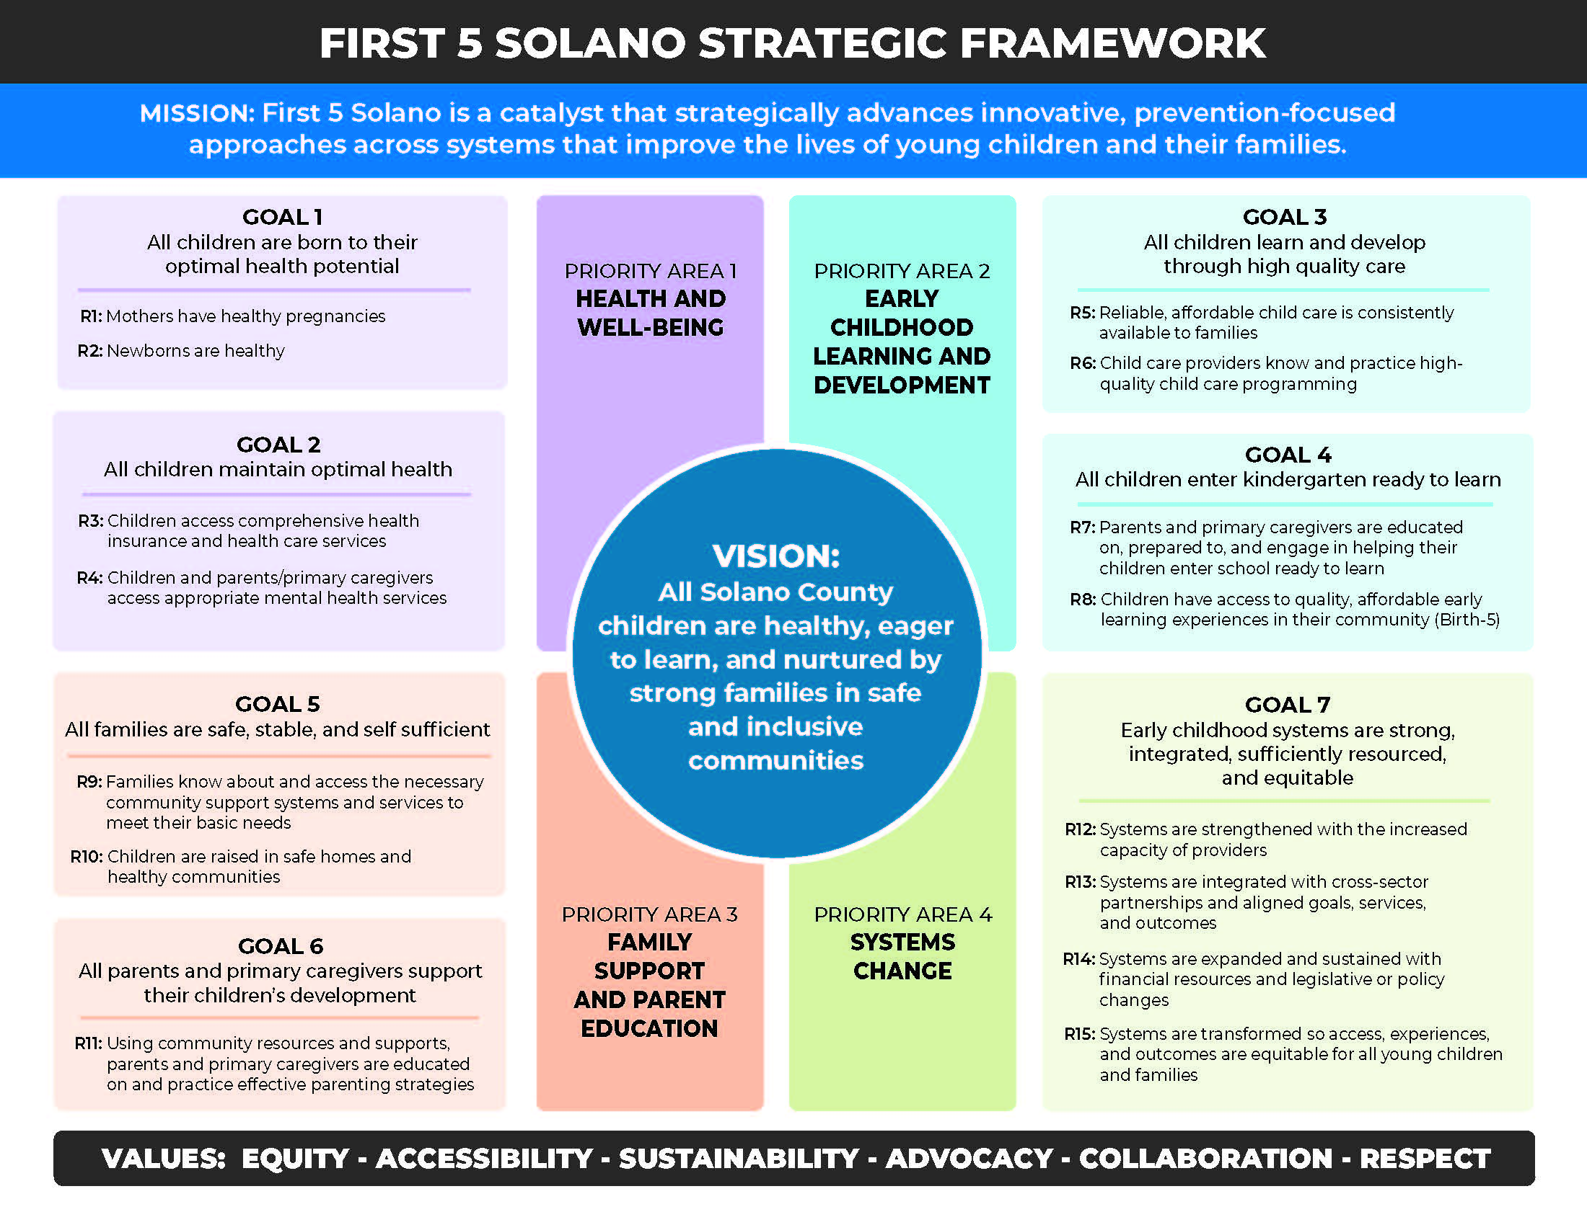

Our commitment to equity and inclusion
First 5 Solano serves one of the most diverse counties in the United States. Our mission and values are deeply rooted in: Equity, Accessibility, Sustainability, Advocacy, Collaboration and Respect. We aim to create an equitable and inclusive culture that fosters acceptance and respect for diversity. In doing so, we seek to deepen understanding and knowledge among children, families, staff, and community partners of diverse backgrounds, cultivate empathy and collaboration, and promote the well-being among our staff, partners and the communities we serve. First 5 Solano celebrates and is enriched by the diversity of our whole community.

Applications
Applications will be accepted for a wide-variety of activities that align with the above Strategic Plan Framework and meet one or more of the following criteria:

- Addresses a gap in service – For example, a successful program for two-year-old’s might be offered in Vacaville but not in Vallejo. Another service gap example could be that there are no programs specifically for new Latino parents in Rio Vista, but there are parents requesting this service.

2. Addresses a community disparity – For example, as seen on the Health and Well-being tab of the community indicators, black babies were most likely to be born low birth weight or preterm. A project partnering with black, pregnant people and supporting them with the prenatal care process would thus address this disparity. For more examples, see community indicator level data:
https://public.tableau.com/app/profile/asr1451/viz/SolanoCountyCommunityIndicators/DataDashboard

3. Addresses a time-sensitive community need – Examples of time-sensitive needs could be a COVID-19 resurgence, a shortage of formula, or increased need in the community for fresh food.

Note: The annual grant may not be used for religious purposes, to benefit an individual, or to promote a candidate for public office. First 5 grantees that are funded for an activity or have been funded in the last 5 years via other First 5 Solano funds may not use annual grant funds for that same activity. Activities funded for projects under this RFA must be new or enhancements to existing activities. Consistent with the intent of the California Children and Families Act of 1998, no monies from this program may be used to supplant state, county or local general fund monies available to the organization for any purpose.

Section 2: Request for Applications Process

Who is eligible to apply?
Nonprofit and for-profit organizations are eligible to apply. Government entities and departments of the County of Solano are not eligible to apply. Only one application per organization will be accepted. Should an organization submit more than one application, the first application received will be considered and any other applications will be returned to the organization without consideration.

- How long is the grant period?

The term of the annual grant is July 1, 2024-June 30, 2025. Any funded projects must be completed before June 30, 2025.

What is the Application Process?
To apply for a grant:
- Review this Request for Applications to see if your proposed project fits the scope of what can be funded.
- Submit a Mandatory Letter of Intent (LOI) by Google forms at:
https://forms.gle/h3z7jTbNQ5YYxEXF7

by February 12, 2024. The LOI indicates that you are interested in applying for an Annual Grant but does not bind you to applying. You must submit an LOI to be eligible to apply. Include any questions you have about the RFA on the LOI. Answers to all submitted questions will be e-mailed directly to everyone who submits an LOI and published on the County’s website.

3) Attend a mandatory grant development session. All potential Applicants that submit an LOI are required to attend a grant development session. These sessions will be held February 12- March 1, 2024. Grant development session appointments and scheduling information will be sent via email as LOI’s are submitted. It is your responsibility to check your email and contact the RFA coordinator if you completed a LOI but have not received an email to schedule a grant development session.

The intent of the grant development session is to assist you in thinking through your grant idea, including:
- What problem are you trying to solve and how does your proposed project solve that problem?
- How does your project align with the First 5 Solano Strategic Plan?
- What is the intended outcome of your project and how will you measure it?
- How does your budget support your project?

4) Complete the attached Application Form (Attachment A) and email it to cfcsolano@solanocounty.com by March 11, 2024, 5:00 PM PST. Late submittals will not be accepted.

D. What if I have questions about the Request for Application?
You can submit questions in writing prior to the Grant Development Session via the LOI. The LOI is due no later than February 12, 2024. You may also ask questions during your Grant Development Session.

Note: Oral communications during the application period and during the grant development session shall be considered unofficial and nonbinding on the County. The County will respond to all questions posed in the LOI by email and by posting the response on the County’s website. These responses will constitute an amendment to the RFA.

E. When is the application due and when will I know if I got the grant?
The following schedule of events reflects important dates for the selection process; however, First 5 Solano reserves the right, at its sole discretion, to adjust this schedule, as it deems necessary. Notification of any adjustment to the Schedule of Events will be posted on the First 5 Solano website (www.first5solano.com). Applicants are responsible to view the website continually for any revisions up to the deadline to submit applications.
Event | Date
First 5 Solano issues Request for Application packet | January 22, 2024
Deadline for submitting written questions via the Letter of Intent (LOI) | February 5, 2024 5:00 PM
Deadline for submitting Letter of Intent (LOI) | February 12, 2024 5:00 PM
First 5 Solano schedules grant development session | February 1- February 22, 2024
Mandatory Grant Development session  30 minute appointments for each Applicant via teleconferencing | February 12 – March 1, 2024
Deadline for submitting an Application | March 11, 2024 5:00 PM PST  Late submittals will not be accepted.
Notice of recommendation of funding | April 10, 2024
Commission considers awards of funding | April 17, 2024
Contract development and Negotiations Period | April 18 - May 27, 2024
Completed Contract Signed by Contractor | June 10, 2024
Activities begin (Note: No activities may begin until contracts are fully executed) | July 1, 2024
1st Quarter (July 15-Sept.30, 2024) Report Due | October 11, 2024
2nd Quarter (Oct.1-Dec.30, 2024) Report Due | January 10, 2025
3rd Quarter (Jan.1-Mar.31,2025) Report Due | April 11, 2025
4th Quarter (April 1-June 30, 2025) Report Due | July 11, 2025

F. What is the Application Format?
Applicants must fully complete the Application in the attached format (Attachment A) adhering to character and page limits where applicable. Applications should be submitted electronically on 8 1/2" x 11" pages, with 1-inch margins, portrait orientation, Arial font size 11. All Application pages should be sequentially numbered, written in English, with all monetary amounts detailed in United States currency and rounded to the nearest whole dollar.

Only electronic submissions will be accepted. Submit application by e-mail to cfcsolano@solanocounty.com with subject line Annual Grants RFA #2024-01 by March 11, 2024 5:00 PM. Late submittals will not be accepted.

NOTE: Applications must be received electronically no later than the Deadline time of 5:00 PM March 11, 2024 as detailed in Schedule of Events in order to be considered.

The County assumes no responsibility for delays caused by any delivery service.

First 5 Solano will not pay any costs associated with the preparation, submittal, or presentation of any Proposal.

E. How will First 5 Solano decide what to fund?

All applications will initially be screened for compliance with the RFA:
- Is the Applicant eligible?
- Did the Applicant submit the mandatory Letter of Intent and attend the grant development session?
- Is the Application complete?
- Is the project within Solano County?
- Do activities benefit children ages 0-5, their parents/caregivers, or provider of services to children ages 0-5 and fall under the Commission’s Strategic Plan priorities?
- If the Applicant receives or has received other funding from First 5 Solano in the past 5 years, is the grant requested for a different activity?

Applicants who pass the initial screening will be forwarded to an Evaluation Committee (EC) composed of First 5 Solano staff and other parties with relevant expertise or experience. The EC will score and recommend proposals according to the criteria below.

A maximum number of points will be assigned to each section:

Application Section | Maximum Score
Program Narrative | 50 Points
Budget | 30 Points
Qualifications and Experience | 20 Points
Total Maximum | 100 Points

Application Evaluation Criteria
Item | Possible Points | Points Total
Program Narrative |  | 50
Applicant provides a clear problem statement and demonstrates the need | 10
Applicant proposes a solution which will meet the demonstrated need. The solution aligns one or more areas within the First 5 Solano Strategic  Framework. | 15
The proposed solution addresses a service gap, community disparity and/or a time-sensitive community need. | 10
Proposed activities and timeline are reasonable to carry out the project. | 5
Applicant proposes a reasonable outcome and a method of measuring it. | 5
At least one component of the project is sustainable beyond the initial project period. | 5
Budget |  | 30
Requested resources are appropriate to carry out the project. | 15
Resources needed to carry out the project are adequately described and clearly connected to the activities in the project description. | 10
Cost per participant is reasonable for services provided. | 5
Qualifications and Experience |  | 20
Applicant clearly articulates the capacity of the organization to accomplish the project. | 15
Applicant describes collaborations and partnerships that strengthen the project. | 5
Total Possible Points |  | 100

Section 3: Contracting Process

Contracting with First 5 Solano
Successful Applicants will be required to sign the Solano County Standard Contract. An example contract with the required terms is attached as Attachment B. Exhibit A [Scope of Work] and Exhibit B [Budget] will be finalized during the contract negotiation process.

Note: Applicants should review sample contract in Attachment B to determine whether you are willing and able to meet the terms of the contract. If there are one or more terms which you are unable or unwilling to meet, you must identify and list the provisions that the Applicant requests be modified along with requested modifications in the Application. If no modifications to the contract are noted, then the Applicant will be deemed capable of performing all requirements under the contract and no further negotiation of the contract will be permitted. Since County contracts are subject to the California Government Code and the Public Contract Code, there are provisions, which must be included in County contracts, which may not be subject to negotiations as solely determined, by County Counsel and Risk Management.

Contracts must be fully executed before activities can begin.

Contractor Responsibilities:
What are your responsibilities if you are awarded a First 5 Solano annual grant?
  - Contract with First 5 Solano for the project you have proposed. Complete any additional necessary paperwork for payment processing, such as a W-9, Solano County Vendor Application, and provide the required certificate of insurance.
  - Participate in 2 First 5 Solano meetings: a project orientation at the start of the project, and a project learning and evaluation session at the end of the project.
  - Participate in First 5 Solano quarterly grantee meetings and a minimum of one individual check-in each quarter with First 5 Solano staff during the project period.
  - Complete the project you proposed in the Application and is in your contract.
  - Acknowledge First 5 Solano in information and advertising about the project.
  - Designate all project related activities as tobacco-free.
  - Collect data as you complete your project. Data should include demographics about who you served including age, race and language, what type of services or activities were provided, as well as outcomes (what changed because of your project). Data collection will be further described in your contract and at the project orientation.
  - Keep track of expenses by type of expense. Reconcile with First 5 Solano at the close of the project.
  - Notify First 5 Solano immediately if you will not be able to complete your project as proposed or if you need to request a modification.
  - Submit a report each quarter, October 11, 2024, January 10, 2025, April 11, 2025 and a final report due by July 11, 2025. Any Applicant that fails to provide these reports may be considered ineligible for future funding.

First 5 Solano Responsibilities:
What are First 5 Solano’s responsibilities should you be awarded an Annual Grant?

  - Prepare the “Standard Contract” for signature.
  - Provide the First 5 Solano logo and associated language for use in advertising and outreach materials.
  - Provide (as requested) community engagement materials, as appropriate and as available.
  - Provide access to training opportunities for organizations staff during the term of the grant.
  - Provide at least two meetings and two technical assistance sessions prior to, during and after the annual grant to meet the administrative requirements of the grant, such as invoicing, data collection and evaluation of the effectiveness of the program.
  - Coordinate support with other First 5 Solano funded programs for related services.

First 5 Solano cannot provide staffing for any grant activities beyond scope listed above, day-to-day supervision of program, or direct purchase of program materials, food, supplies or equipment.

Funding and Payment Structure
First 5 Solano will provide funding in 2 payments. The first payment will be made for 50% of the grant award upon full execution of the contract and submittal of necessary forms for payment. The second payment will be made upon completion of the project and submittal of a final invoice by July 13th, 2025 of all costs associated with the project and agreed upon in the contract, up to the total grant amount.

Grant funds must be utilized in the fiscal year in which they are issued. Any funds not utilized in the fiscal year in which they were issued must be returned to First 5 Solano within 30 days after completion of contract.

Section 4: First 5 Solano Reservation of Rights

- First 5 Solano reserves the right to reject any and all Applications, or to cancel this RFA in part or in its entirety.
- First 5 Solano reserves the right to waive any variances in applications provided such action is in the best interest of First 5 Solano.
- First 5 Solano reserves the right to amend this RFA at any time. First 5 Solano also reserves the right to cancel or reissue the RFA at its sole discretion.
- Any application received which does not meet the requirements of this RFA, may be considered to be non-responsive, and may be rejected. First 5 Solano may reject any application that does not comply with all of the terms, conditions, and performance requirements of this RFA.
- First 5 Solano reserves the right to cancel any award and re-solicit bids for services herein specified due to the increased or added costs, if in its opinion increased prices are greater than those of the general market.
- First 5 Solano reserves the right to cancel any award and re-solicit bids in the event services cannot commence within ten (10) days after the specified date for start of work.
- First 5 Solano reserves the right to reject any and all proposals considered not to be in the best interest of First 5 Solano.
- First 5 Solano reserves the right to reduce or increase any specification, in whole or in part due to budget constraints.

