Solano County General Services Department
Parks And Recreation Division
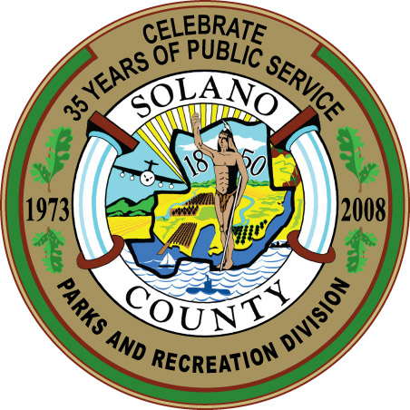
Spencer C. Bole
Director, General Services
Daniel R. Sykes
Parks Services Manager
Daniel R. Sykes
675 Texas Street, Suite 2500
Fairfield, CA 94533
(707) 784-3118
Park & Recreation Manager

AGENDA -- Park and Recreation Commission
Thursday, March 11, 2010 - 5:30 PM
Hearing Room - 1st Floor
675 Texas Street, Fairfield, CA

- Call to Order and Roll Call
- Approval of Minutes for the January 14 and February 4 Meetings (Action Item)
- Approval of Agenda (Action item)
- Chair Announcements and Commissioner Comments (Informational Only)
- Public Comments
- Approve Timeline for Fish and Wildlife Propagation Fund (FWPF) Program and Provide Direction on Formation of FWPF Evaluation Committee (Action Item)
- Discuss Possible Commission Involvement and Formation of Ad Hoc Committees (Discussion, with Possible Action)
  - County Parks Speaker’s Bureau
  - Ad Hoc Committee to Review State Fish and Game Rulemaking
  - Response to Fish Stocking Issue at Lake Solano

- Parks and Recreation Division Staff Report (Informational Only)
- Revenue and Attendance Tracking
- Ongoing Plans for Parks Revenue and Marketing
- Update on Ongoing SMSF and FWPF Grant Projects

- Committee Reports (Informational, with Possible Action)
  - Nature Center Facility Use Committee – discuss next steps, research needs

- Confirm next regular meeting of May 13, 2010 at 5:30 pm, and adjourn

The County of Solano does not discriminate against persons with disabilities and is an accessible facility. If you wish to attend this meeting and you will require assistance in order to participate, please call (707) 784-7905 at least 24 hours in advance of the event to make reasonable arrangements.

If you wish to address any item listed on the Agenda, please submit a Speaker Card before the Commission considers the specific item. If you wish to address an item not on the agenda, please submit a Speaker Card before the first speaker is called for Public Comments. Cards are available at the entrance to the hearing room All non-confidential materials provided to the Commission may be obtained by first calling (707) 784-7905 and picking them up at 675 Texas Street, Suite 2500, Fairfield

