Solano County General Services Department
Parks And Recreation Division
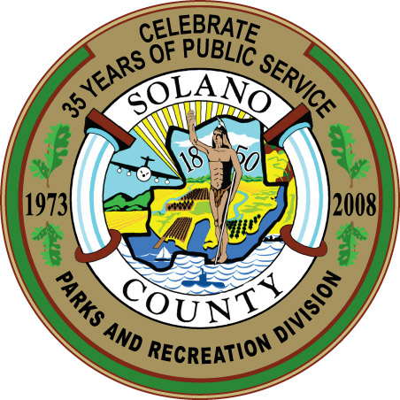
Spencer C. Bole
Director, General Services
Daniel R. Sykes
Parks Services Manager
Daniel R. Sykes
675 Texas Street, Suite 2500
Fairfield, CA 94533
(707) 784-3118
Park & Recreation Manager

AGENDA -- Park and Recreation Commission
Thursday, July 9, 2009 - 5:30 PM
Hearing Room - 1st Floor
675 Texas Street, Fairfield, CA

- Call to Order and Roll Call

- Approval of Minutes for the June 3, 2009 Special Meeting (Action Item)

- Approval of Agenda (Action item)

- Chair Announcements and Commissioner Comments (Informational Only)

- Parks and Recreation Division Staff Report (Informational Only)
- Parks Activities Report
- FY2009/10 Budget Impacts on Parks Services and Lynch Canyon Open Space
- Review of FY2008/09 Suisun Marsh Specific Fund Grant Program

- Discussion of Future Commission Agenda Items (Action Item)

- Committee Reports (none scheduled)

- Public Comments

- Confirm next regular meeting of September 10, 2009 at 5:30 pm, and adjourn

The County of Solano does not discriminate against persons with disabilities and is an accessible facility. If you wish to attend this meeting and you will require assistance in order to participate, please call (707) 784-7905 at least 24 hours in advance of the event to make reasonable arrangements to ensure accessibility to this meeting.

If you wish to address any item listed on the Agenda, please submit a Speaker Card before the Commission considers the specific item. If you wish to address an item not on the agenda, please submit a Speaker Card before the first speaker is called for Public Comments. Cards are available at the entrance to the hearing room.

