May 2015
Realignment, Incarceration, and Crime Trends in California
Magnus Lofstrom | Steven Raphael | Research support from Brandon Martin
Summary
When California’s historic public safety realignment was implemented in October 2011, many were concerned about the impact it would have on crime rates. In a 2013 report, we found that realignment did not increase violent crime in its first year, but that it did lead to an increase in auto thefts. In this report, we assess whether these trends continued beyond realignment’s first year. We find that both the prison and jail populations increased slightly since 2012, which means that the number of offenders on the street did not rise from the 18,000 during realignment’s first year. This is likely to change with the implementation of Proposition 47, which further reduces California’s reliance on incarceration. Our analysis of updated state-level crime data from the FBI confirms our previous findings. Violent crime rates remain unaffected by realignment, and although California’s property crime rate decreased in 2013, it did not drop more than in comparable states—so the auto theft gap that opened up in 2012 has not closed. Research indicates that further reductions in incarceration may have a greater effect on crime trends; the state needs to implement effective crime prevention strategies—and it can learn about alternatives to incarceration successfully implemented by the counties as well as other states.
Realignment Continues to Unfold
California’s public safety realignment, prompted by a federal court mandate to reduce overcrowding in its expensive prison system, is in its fourth year of implementation. The reform decreased the state’s reliance on incarceration by changing the sentencing of non-serious, non-violent, and non-sexual felonies and modifying the sanctions for parole violators. Importantly, realignment shifted the responsibility for many lower-level offenders from the California Department of Corrections and Rehabilitation (CDCR) to county jail and probation systems.1
Realignment reduced the prison population by about 27,000 by September 2012, the first year of the reform. County jail populations increased by only 9,000, which offset roughly one third of the decline in the prison population. The overall reduction in incarceration meant that more former inmates were on the street, which led to concerns about realignment’s impact on the long-run decline in state crime rates. Though 2012 crime data revealed increases in both violent and property crime, our 2013 PPIC report showed that these concerns were mostly unwarranted. We found no evidence that the increase in violent crime was greater than increases in appropriate comparison states. Part of the increase in property crime could be attributed to the prison population decline, but that impact was modest and limited to auto thefts.2
In this report, we extend our analysis to assess whether these trends continued into the second year of the reform.3 It is possible that counties refined their strategies and identified more effective crime prevention approaches. It is also possible that the increase in responsibilities and potentially insufficient resources limited the counties’ ability to do this.
Incarceration Trends
We begin by determining whether the substantial decrease in incarceration continued beyond the first year of realignment. Data on incarceration are more recent than crime data (currently limited to 2013 and earlier), so we can examine the prison population through February 2015 and the jail population through June 2014.
The Prison Population Did Not Continue Its First-Year Decline
In September 2011, the month before realignment was implemented, California’s prison population stood at 160,700, or 431 inmates per 100,000 residents (Figure 1). Three months later it had dropped to 144,000, and by September 2012 it had fallen to 133,400 (355 inmates per 100,000 residents). After that, the population increased slowly until November 2014, when voters passed Proposition 47.4 After that, the prison population dropped by almost 5,000, to about 131,200 (or 341 inmates per 100,000 residents). This reduction—along with the increased use of in-state contract beds in both public and private facilities and the opening of a new health care facility in Stockton—has reduced overcrowding and brought the prison population into compliance with the federal court–ordered target of 137.5 percent of design capacity. The prison population now stands at 136.1 percent of design capacity, about 1,200 inmates below the mandate, ahead of the February 2016 deadline.5
Figure 1. After a big first-year drop, the prison population stopped declining until Proposition 47 passed
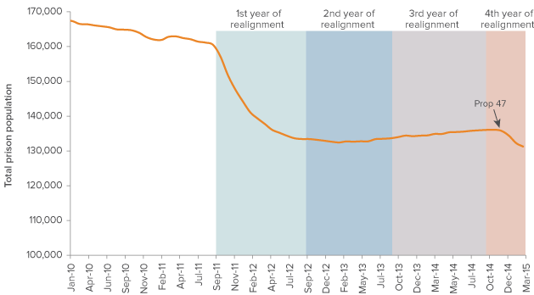
SOURCE: California Department of Corrections and Rehabilitation, Weekly Population Report, January 2010–February 2015.
NOTE: Total prison population as of the last day of the month.
County Jail Populations Are Growing at a Slower Rate
With the diversion of both newly sentenced lower-level felons and parole violators to county jail, California’s average daily jail population (ADP) increased significantly by the end of the first year of realignment (from about 71,800 to 80,900). California’s jail incarceration rate increased from about 191 per 100,000 residents before realignment to 214 a year later. Since then the rate has not changed much and now stands around 216. Although the county jail population has continued to rise, it is increasing at a much slower rate. The monthly average daily population increased by 1,800 in the second year of realignment and by an additional 350 in the first nine months of the third year. In other words, about 80 percent of the post-realignment increase in the jail population took place in the reform’s first year.
With a number of jails operating at full capacity and under court ordered population caps, increases in the jail population do not fully indicate realignment’s impact on incarceration. Early releases of jail inmates prompted by these population caps (known as capacity-constrained releases) also increased noticeably in the first year of realignment, from a monthly average of about 10,700 the year immediately before realignment to 12,300 during its first year, an increase of roughly 15 percent.6 Average capacity constrained releases went up in the second year by about 700, and now hover around 13,100.
Figure 2. Jail populations have increased slowly since the first year of realignment
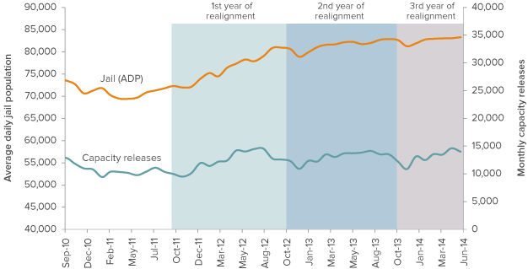
SOURCE: Board of State and Community Corrections, Jail Profile Survey, January 2010–June 2014.
The Total Incarceration Rate Is Holding Steady
Overall, the data quite clearly show that realignment’s impact on both jail and prison incarceration was concentrated in the first year of implementation. The decline in prison population was not matched by the increase in jail population, so the combined jail and prison incarceration rate dropped from 619 per 100,000 residents to 566. Between September 2012 and June 2014, the combined jail and prison populations have increased at a pace slightly above the overall rate of population growth in the state. The total incarceration rate has increased only marginally, by 0.3 percent, to 568 inmates per 100,000 residents.7 Furthermore, capacity-constrained releases have leveled off.
In sum, the number of offenders not incarcerated as a result of realignment changed very little after the first year of the reform. It will be important to track the impact of Proposition 47—the prison population data reveal a noticeable drop of about 5,000 in the first four months since its passage in November 2014. But so far, to the extent that the overall decline in the incarceration rate was the main determinant behind the 2012 increase in property crime,8 our analysis suggests no additional impact of realignment on crime in 2013, unless the impact occurred with a delay.
California’s Crime Rates Declined in 2013
The Federal Bureau of Investigation’s (FBI) Uniform Crime Report data show that after increasing slightly in 2012, California’s violent crime rate dropped by 6.4 percent in 2013, to a 46-year low of 396 per 100,000 residents. As shown in Figure 3, the greatest percentage decrease in 2013 was in the murder rate, which dropped 8 percent—from 5 homicides per 100,000 residents to 4.6. But other violent crime categories also saw declines that ranged from 5.3 percent (rape) to 6.8 percent (aggravated assault).
Figure 3. California saw declines in all violent offense categories in 2013
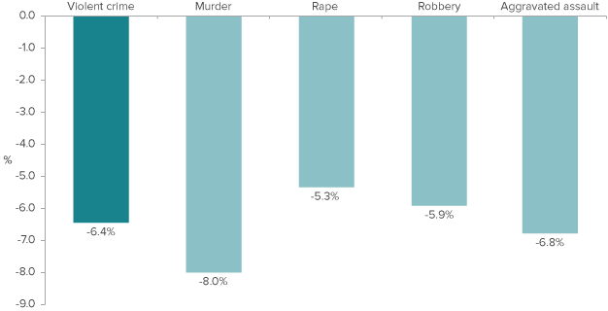
SOURCE: FBI, Uniform Crime Reports, 2012–13.
NOTE: The percentage changes refer to the 2012–13 change in the crime rate, defined as number of crimes per 100,000 residents. Violent crime includes homicide, rape, robbery, and aggravated assault.
Property crime increased quite noticeably in 2012—by 7.8 percent—but dropped in 2013 by 3.8 percent (Figure 4). The decline was seen in all property crime categories, ranging from a 6.4 percent drop in burglaries to 2.8 percent in motor vehicle thefts. In spite of the drop in motor vehicle thefts from 444 per 100,000 residents to 431, California continues to have the highest auto theft rate in the country.
Figure 4. Property crime declined by less than violent crime in 2013
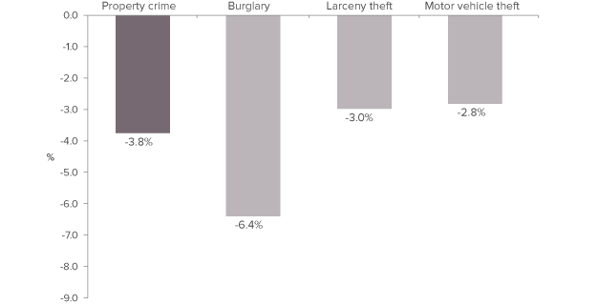
SOURCE: FBI Uniform Crime Reports, 2012–13.
NOTE: The percentage changes refer to the 2012–13 change in the crime rate, defined as number of crimes per 100,000 residents. Property crime includes burglary, motor vehicle theft, and larceny theft (including non-felonious larceny theft).
The encouraging news that crime rates have returned to their long-term declining trend might suggest that the 2012 increase was an anomaly. To better understand the extent to which this is true, we turn to a comparison of California’s crime trends to those of other states. If the observed 2012 increase in property crime was truly unrelated to realignment, we might expect California’s 2013 decline in crime rates to reduce or erase the gap between California and comparison states estimated in our 2013 report.
How Does California’s Decline Compare to Other States?
The FBI crime data show that the 2013 drop in violent crime rates in California was somewhat greater than, but roughly in line with, changes in other states. Table 1 shows that the statewide decline in violent crimes was slightly greater than the national average. Eighteen states experienced a greater decrease in the violent crime rate than California’s 6.4 percent, and 17 to 26 states experienced greater drops in murder, rape, robbery, and aggravated assault rates. California’s decline in violent crimes is greater than declines in neighboring states but less than what was observed in two other western states, Washington and Montana.
Table 1. The 2013 drop in California’s violent crime rates was comparable to declines in most other states
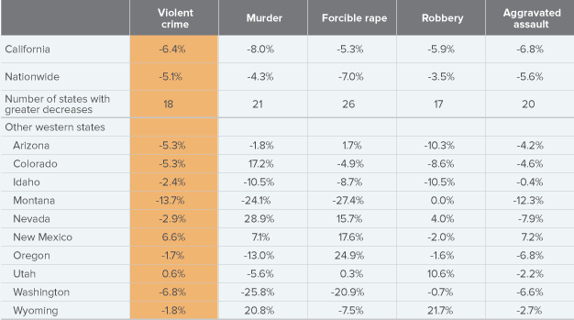
SOURCE: FBI Uniform Crime Reports, 2012–13.
NOTE: The percentage changes refer to the percent change in the number of crimes per 100,000 residents between 2012 and 2013.
Property crime declined less in California than in the U.S. as a whole (Table 2). Thirty-three states saw greater property crime decreases than California. California’s property crime rate fell by less than the rates in three western states (Arizona, Idaho, and Wyoming). A handful of western states saw increases in property crime, including Nevada, New Mexico, and Washington.
Overall, the data suggests that the 2013 changes in crime in California do not stand out compared to trends nationwide or in neighboring and other western states.
Table 2. California’s 2013 property crime decrease was less than that of most other states
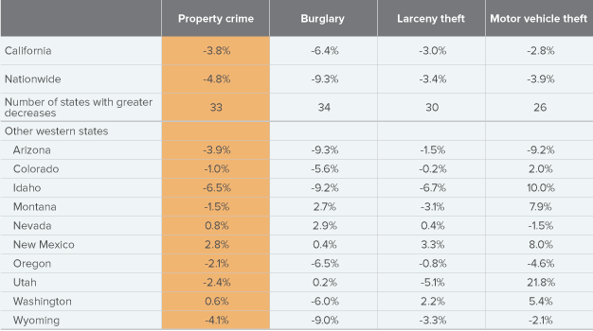
SOURCE: FBI Uniform Crime Reports, 2012–13.
NOTE: The percentage changes refer to the percent change in the number of crimes per 100,000 residents between 2012 and 2013.
Simple comparisons between California and other states cannot tell us conclusively whether its trends are truly unique. To determine whether crime trends have been affected by realignment, we identified a combination of states that best represents what California’s crime rates would have been had the state not implemented realignment.
Realignment’s Modest Impact
As we did in our previous report, we use a data driven matching strategy to identify a combination of states with crime trends similar to California’s prior to realignment (the so-called synthetic control method).9 The post-realignment crime trends of this matched group of states best represent what the crime rates would have been in California had the state not implemented realignment.
There is still no evidence that realignment has affected violent crime. Figure 5 shows that California’s violent crime rate continues to follow the trend of its comparison states. Post-realignment changes in violent crime in California fluctuate in ways that are similar to the comparison states, and none of the deviations from the trend are statistically significant.10 We also analyze each of the four violent crime offense trends separately and find that changes in rates of murder, rape, aggravated assault, and robbery in California do not stand out when compared to changes in other states.11
Figure 5. California’s violent crime trend continues to match trends in comparison states
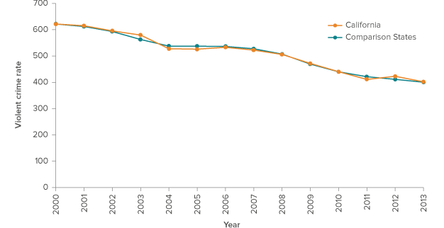
SOURCE: Authors’ estimates based on annual state level data from the FBI’s Uniform Crime Reports, 2000–2013.
NOTE: The matched comparison states (with estimated weights in parentheses) are Florida (0.338), Maryland (0.161), Montana (0.068), New York (0.214), Rhode Island (0.191), and South Carolina (0.029).
Our analysis of property crime trends shows that the gap between California and other states that emerged in 2012 remains unchanged in 2013. Figure 6 shows that California’s pre-realignment property crime trend can be closely matched to that of a set of comparison states. The trends start to diverge in 2011, the year in which realignment was implemented; by 2012 there was a noticeable gap. In 2013, California’s property crime rate declined, but not at a greater rate than in comparable states. Our analysis of the three property offense categories of burglary, larceny theft, and motor vehicle theft reveals that the post-realignment increase in property crime has been driven by an increase in the auto theft rate.12
Figure 6. The property crime rate gap between California and comparison states persisted in 2013
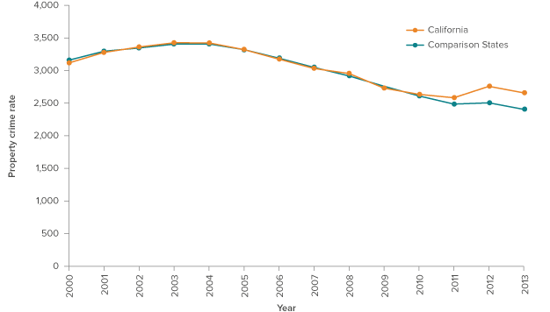
SOURCE: Authors’ estimates based on annual state level data from the FBI’s Uniform Crime Reports, 2000–2013.
NOTE: The matched comparison states (with estimated weights in parentheses) are Colorado (0.033), Georgia (0.001), Kentucky (0.133), Massachusetts (0.032), Nevada (0.163), Tennessee (0.075), West Virginia (0.041), and Wyoming (0.522).
Policy Implications
As we have seen, one of realignment’s major effects in its first four years has been to decrease California’s reliance on incarceration. The state prison population has declined substantially without causing a corresponding one-to-one increase in the county jail population. As of June 2014, the state’s incarceration rate had dropped by slightly more than 8 percent, from 622 inmates per 100,000 residents to 570. Importantly, our research shows that this reduction has had a very limited impact on crime. As we reported in our earlier work, and updated here with 2013 crime data, our analyses reveal no evidence that realignment has so far had an impact on violent crime rates. The only effect we can attribute to realignment is a noticeable rise in motor vehicle thefts. Our estimates indicate that realignment increased the auto theft rate by slightly more than 70 per 100,000 residents, an increase of about 17 percent.
From a cost-benefit perspective, incarceration does prevent some crime, but at current rates its effect is very limited.13 The estimated crime preventive effects remain unchanged from our earlier report: each additional dollar spent on incarceration generates only 23 cents in "crime savings.” This suggests that the state would benefit from seeking alternative crime preventive strategies. There are many promising approaches—from early childhood programs and targeted interventions for high-risk youth to increased policing and cognitive behavioral therapy. Also promising are alternative systems for managing probationers and parolees—including swift-and-certain yet moderate sanctions that have been implemented by systems such as Hawaii’s Opportunity Probation with Enforcement (HOPE).
Arguably, it is more important than ever to identify and implement effective strategies in California. The recently passed Proposition 47, which converted a number of drug and property offenses from felonies to misdemeanors, will further decrease California’s reliance on incarceration. At high incarceration rates, reduced reliance on incarceration appears to have a small and very limited effect on crime, but this effect might become larger with further declines.14 Hence, it is particularly important to redirect incarceration savings to effective crime-preventive strategies, such as those mentioned above. Additionally, realignment’s shift of responsibilities from the state to the county level means that a number of strategies have already been implemented—some more successfully than others.15 More resources should be devoted to identifying effective alternative strategies and determining whether those efforts can be expanded and replicated around the state.
Share
Print
Download PDF
NOTES
Realignment shifted responsibility and funding from the state in three main ways. First, lower-level offenders convicted of non-sexual, non-violent, and non-serious (so-called triple-non) crimes and who have no sexual, serious, or violent crimes in their criminal records now serve their sentences under county supervision rather than in state prisons. Second, parole violators who violate the terms of their release but are not convicted of a new felony are no longer sent to state prison but serve short stays in county jails or face other local sanctions. Third, most offenders serving time in state prison for triple-non offenses will now, upon release from prison, be supervised by county probation departments rather than state parole. Realignment also reduced the maximum incarceration period for probation or parole violations from one year to six months.
Magnus Lofstrom and Steven Raphael, Public Safety Realignment and Crime Rates in California, (PPIC 2013).
It is important to note that crime data are currently available only through 2013, which limits our analysis of realignment’s potential impact on crime to roughly the first two years (27 months, to be precise) of the reform.
Proposition 47 classifies a number of drug and property offenses as misdemeanors instead of felonies or wobblers (wobblers may be charged as misdemeanors or felonies at the discretion of the prosecutor). Moreover, the new law—which went into effect November 5—permits offenders to file for resentencing, meaning that those who are resentenced could be released from jail or prison.
California was sued in federal court for providing inadequate mental health care and medical care to its prison inmates. As a result, in 2007 a three-judge panel determined that excessive crowding in the state’s prisons prevented improved conditions and ordered the state in 2009 to reduce its institutional population to 137.5 percent of design capacity. The state appealed to the U.S. Supreme Court, which upheld the mandate in May 2011.
Given that there are no currently available data on the extent to which capacity-constrained releases shorten sentences, we do not know how many additional offenders are on the street as a result of this increase.
As of June 2014, the most recent month for which statewide jail population data is available.
Lofstrom and Raphael, Public Safety Realignment and Crime Rates in California.
For more detail about the application of the synthetic control method in this context, see the Technical Appendix to Lofstrom and Raphael, Public Safety Realignment and Crime Rates in California.
To test whether the differences between California and the matched comparison states are statistically significant, we re-run the matching process for the other states, generating a set of matched states for each and then comparing the observed post-realignment differences to the pre-realignment-year differences. A ranking of the magnitude of the estimated changes tells us whether California’s changes stand out and provides the basis for statistical significance. California’s post-realignment change would be statistically significant at the commonly used 5 percent significance level if it ranked first or second. At a 10 percent significance level, the change would need to be ranked fourth or higher. California’s post-realignment change in the violent crime rate ranks no higher than 14th when we simulate a policy change in all other states.
California’s post-realignment change in each of the violent offense category never ranks higher than 10th when we simulate a policy change in all other states.
California’s post-realignment increase in motor vehicle theft is larger than increases in the other states and subsequently ranks first. The increases in burglaries and larceny thefts never rank higher than 10th and hence are statistically insignificant.
Although inherently difficult and controversial, the crime prevention associated with incarceration can be assessed in the context of cost-benefit analysis. Assuming that costs associated with crime can be measured reliably, the costs of crimes avoided due to incarceration—a benefit—can be juxtaposed against the costs of incarceration. Clearly, the costs associated with violent crime are both more controversial and more difficult to ascertain than are the costs associated with property crime. Nonetheless, there is a growing body of research that places a dollar value on the social costs of specific criminal offenses. The general approach is to obtain estimates of so-called willingness-to-pay to reduce the probability of experiencing an undesirable outcome, such as having one’s car stolen (this is similar to the approach used to generate estimates of other difficult-to-determine costs such as those associated with pollution). See Paul Heaton, "Hidden in Plain Sight: What Cost-of-Crime Research Can Tell Us about Investing in Police” (RAND 2010) for a summary of the approaches used and societal crime cost estimates based on the relevant literature.
See for example Raymond Liedka, Anne Morrison Piehl, and Bert Useem, "The Crime Control Effect of Incarceration: Does Scale Matter?” Criminology and Public Policy 5 (2006): 245–75; Paolo Buonanno and Steven Raphael, "Incarceration and Incapacitation: Evidence from the 2006 Italian Collective Pardon,” American Economic Review 103 (2013): 2437–65; and Lofstrom and Raphael, Public Safety Realignment and Crime Rates in California.
Jeffrey Lin and Joan Petersilia, Follow the Money: How California Counties Are Spending Their Public Safety Realignment Funds (Stanford Criminal Justice Center, 2013); Mia Bird and Ryken Grattet, Do Local Realignment Policies Affect Recidivism in California? (PPIC 2014). Some early evidence of a certain degree of success is that in spite of reduced incarceration as a sanction for parole violations (as a result of lower maximum sentence for a parole violation and jail capacity constraints), recidivism rates did not increase in the first year of realignment. In fact, the one-year re-arrest rate of offenders released from state prison declined by about 2 percentage points compared to pre-realignment releases. See Lofstrom, Raphael, and Grattet, Is Public Safety Realignment Reducing Recidivism in California? (PPIC 2014).
Back to top
ACKNOWLEDGMENTS
This report has benefited significantly from comments and suggestions by Mia Bird, Sarah Bohn, Emma Hughes, Mary Severance, Drew Soderborg, and Lynette Ubois.
ABOUT THE AUTHORS
Magnus Lofstrom is a senior fellow at PPIC. His areas of expertise include public safety, immigration, entrepreneurship, and education. His recent work examines crime trends in California, public safety realignment and recidivism, and California’s jail capacity and construction needs. He also holds appointments as research fellow at the Institute for the Study of Labor (IZA), Germany, community scholar at the Julian Samora Research Institute at Michigan State University, and research associate at the Center for Comparative Immigration Studies at the University of California, San Diego. He serves on the editorial board of Industrial Relations and was a member of California State Controller John Chiang’s Council of Economic Advisors. Prior to joining PPIC, he was an assistant professor of economics at the University of Texas at Dallas. He received his PhD in economics from the University of California, San Diego.
Steven Raphael is an adjunct fellow at the Public Policy Institute of California and professor of public policy at the University of California, Berkeley. His research focuses on the economics of low-wage labor markets, housing, and the economics of crime and corrections. He is the author of The New Scarlet Letter? Negotiating the U.S. Labor Market with a Criminal Record and Why Are So Many Americans in Prison? (with Michael Stoll). He is the editor in chief of Industrial Relations: A Journal of Economy and Society and a research fellow at the University of Michigan National Poverty Center, the University of Chicago Crime Lab, and the Institute for the Study of Labor (IZA), Germany. He holds a PhD in economics from the University of California, Berkeley.
Other Publications
Public Safety Realignment and Crime Rates in California
California’s Future: Corrections
© 2015 Public Policy Institute of California
The Public Policy Institute of California is dedicated to informing and improving public policy in California through independent, objective, nonpartisan research. PPIC is a public charity. It does not take or support positions on any ballot measure or on any local, state, or federal legislation, nor does it endorse, support, or oppose any political parties or candidates for public office.
Short sections of text, not to exceed three paragraphs, may be quoted without written permission provided that full attribution is given to the source.
Research publications reflect the views of the authors and do not necessarily reflect the views of the staff, officers, or board of directors of the Public Policy Institute of California.
Public Policy Institute of California
500 Washington Street, Suite 600
San Francisco, CA 94111
T 415 291 4400 F 415 291 4401
PPIC Sacramento Center
Senator Office Building
1121 L Street, Suite 801
Sacramento, CA 95814
T 916 440 1120 F 916 440 1121

