Solano County Park and Recreation Commission
General Services Department
Steve Hermsmeyer, Chair
Park and Recreation Commission

Daniel Sykes
Parks Services Manager

675 Texas Street, Suite 2500
Fairfield, CA 94533
707-784-3118
DRSykes@SolanoCounty.com
Daniel R. Sykes
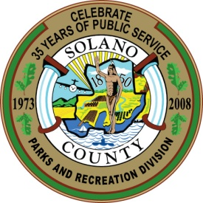
Park & Recreation Manager

AGENDA -- Park and Recreation Commission
Thursday, May 12, 2011 - 5:30 PM
Hearing Room - 1st Floor, 675 Texas Street, Fairfield, CA

- Call to Order and Roll Call
- Approval of Minutes from March 10, 2011 (Action Item)
- Approval of Agenda (Action Item)
- Chair and Commissioner Announcements (Informational Only)
- Public Comments
- Receive Presentation on the Putah Creek Trout Organization and Activities at Lake Solano. By Steve Karr, Chair of the Board, Putah Creek Trout (Informational)
- Discuss Options to Revive Fishing and the Fishery at Lake Solano (Informational, With Possible Action)
- Review and Comment on California State Parks’ “Recreation Proposal for the Sacramento-San Joaquin Delta and Suisun Marsh” (Action)
- Receive “Year 4 Annual Assessment of Operations for Lynch Canyon Open Space Park” (Informational)
- Receive Parks and Recreation Division Staff Report (Informational)

- Attendance and Revenue Update (handout)
- Status of FWPF and SMSF Grant Projects (handouts)
- Status of Lynch Canyon Management Agreement (oral)
- Transfer of County Parks to Resource Management Department (oral)
- Confirm next Regular Meeting of July 14, 2011, 5:30 pm, and adjourn

The County of Solano does not discriminate against persons with disabilities and is an accessible facility. If you wish to attend this meeting and you will require assistance in order to participate, please call (707) 784-7905 at least 24 hours in advance of the event to make reasonable arrangements to ensure accessibility to this meeting.

If you wish to address any item listed on the Agenda, please submit a Speaker Card before the Commission considers the specific item. If you wish to address an item not on the agenda, please submit a Speaker Card before the first speaker is called for Public Comments. Cards are available at the entrance to the hearing room.

